Software Design Specification

for

Online Store-House Booking System

Prepared by

Al Musabbir - 1611158042

Md. Rafat Rahman Tushar - 1621450042

Raisa Mehjabin Azni - 1620216042

Monjur A-Elahi Tanmoy – 1620587042

Course: CSE327

Sec: 06

North South University

Summer 2019

Table of Contents

1. Purpose

2. Architectural Design

3. Architectural Pattern

4. ER Diagram

5. Database Schema

6. Use Case Diagram

7. Class Diagram

8. Sequence Diagrams

**Purpose**

Nowadays, the small businesses and start-ups are growing at a large scale. But the capacity, space is a major concern in this kind of businesses. They need to store their necessary products somewhere else. But going to store by store without knowing the capacity and other information regarding the store-house is a problem for the businessman. Moreover, many store owners can’t get enough customers by traditional methods. Our purpose is to create an app that can solve this problem by connecting the store owners and the businessmen. Basically, we are building this application focusing all kind of criteria regarding this scenario. We are also building this application on the basis of users’ requirements.

**Architectural design**

The software basically has 2 components. The frontend UI for both admins and end users, and the database that only admins will see and interact with.

**Architectural pattern**

The application will be developed in the MVC architectural style. There are three main components to it

- Model component, which manages the data

- View component, which determines how the data is presented

- Controller component, that manages the both model and view components.

The purpose of using MVC is to separate the user interface from the logic so that it is easier to handle and this makes it more flexible to alter data or its representation. Hence being an easy option for applications.

ER Diagram

User_shipper

Sh_guy_vehicle_id:varchar Sh_car:varchar Vehicle_status:varchar Fee_per_kilo:double Vehicle_rating:double Vehicle_owner_rating:double Sh_policies_&_licenses:varchar

Shipper

User_bus

Bus_id:varchar Bus_name:varchar Bus_owner:varchar Bus_products:varchar Bus_house_no:int Bus_road_no:int Bus_area/vill:varchar Bus_po:varchar Bus_pcode:int Bus_thana:varchar Bus_district:varchar Bus_shipping_vehicle:varchar Bus_policies_&_licenses:varchar

Business

User_store

Store_id:varchar Store_name:varchar Store_owner:varchar Material_types:varchar Capacity:int Available_space:int Store_house_no:int Store_Road_no:int Store_area/vill:varchar Store_po:varchar Store_pcode:int Store_thana:varchar Store_district:varchar Store_shipping_vehicle:varchar Fee_per_kilo_shipping:double Fee_per_day_per_100_product_storing:double Subscription_status:varchar Subscription_expiry:DateTime Store_rating:double Store_owner_rating:double Policies_&_licenses:varchar

Store

User

User_id:varchar Password:varchar Email:varchar Phn:int Name:varchar Type:varchar

Admin_id:varchar Admin_pword:varchar

Admin

Shiper_order

Shipping_order

Sh_or_no:int Sh_guy_vehicle_id:varchar Order_no:varchar From_whr:varchar To_whr:varchar Departure:DateTime Arrive:DateTime Estimated_arrival_time:DateTime Reached?:varchar Paid?:varchar

Order_ship

Order

Order_no:int Store_id:varchar Bus_id:varchar Product_type:varchar Product_size/weight:varchar From_when:DateTime To_when:DateTime Quantity:double Sh_from_whr:varchar Sh_to_whr:varchar

Pay_order

Str_Bu_Or

Stored_item

Payment_account

Store_item_id:varchar Bus_id:varchar Store_id:varchar Order_no:int Product_name:varchar Product_size:varchar From_date:DateTime To_Date:DateTime Product_status:varchar

Str_itm_order

Store_id:varchar Bus_id:varchar Sh_guy_vehicle_id:varchar Payment_method:varchar Account_no:varchar

Database Schema

Admin(Admin_id:varchar, Admin_pword:varchar)

User(User_id:varchar, Password:varchar, Email:varchar, Phn:int, Name:varchar, Type:varchar)

User_bus(User_id:varchar, Bus_id:varchar)

Business(Bus_id:varchar, Bus_name:varchar, Bus_owner:varchar, Bus_products:varchar, Bus_house_no:int, Bus_road_no:int, Bus_area/vill:varchar, Bus_po:varchar, Bus_pcode:int, Bus_thana:varchar, Bus_district:varchar, Bus_shipping_vehicle:varchar, Bus_policies_&_licenses:varchar)

User_store(User_id:varchar, Store_id:varchar)

Store(Store_id:varchar, Store_name:varchar, Store_owner:varchar, Material_types:varchar, Capacity:int, Available_space:int, Store_house_no:int, Store_Road_no:int, Store_area/vill:varchar, Store_po:varchar, Store_pcode:int, Store_thana:varchar, Store_district:varchar, Store_shipping_vehicle:varchar, Fee_per_kilo_shipping:double, Fee_per_day_per_100_product_storing:double, Subscription_status:varchar, Subscription_expiry:DateTime, Store_rating:double, Store_owner_rating:double, Policies_&_licenses:varchar)

User_shipper(User_id:varchar, Sh_guy_vehicle_id:varchar)

Shipper(Sh_guy_vehicle_id:varchar, Sh_car:varchar, Vehicle_status:varchar, Fee_per_kilo:double, Vehicle_rating:double, Vehicle_owner_rating:double, Sh_policies_&_licenses:varchar)

Order(Order_no:int, Store_id:varchar, Bus_id:varchar, Product_type:varchar, Product_size/weight:varchar, From_when:DateTime, To_when:DateTime, Quantity:double, Sh_from_whr:varchar, Sh_to_whr:varchar)

Shipping_order(Sh_or_no:int, Sh_guy_vehicle_id:varchar, Order_no:varchar, From_whr:varchar, To_whr:varchar, Departure:DateTime, Arrive:DateTime, Estimated_arrival_time:DateTime, Reached?:varchar, Paid?:varchar)

Payment_account(Store_id:varchar, Bus_id:varchar, Sh_guy_vehicle_id:varchar, Payment_method:varchar, Account_no:varchar)

Stored_item(Store_item_id:varchar, Bus_id:varchar, Store_id:varchar, Order_no:int, Product_name:varchar, Product_size:varchar, From_date:DateTime, To_Date:DateTime, Product_status:varchar)

Pay_order(Store_id:varchar, Bus_id:varchar, Sh_guy_vehicle_id:varchar, Payment_method:varchar, Account_no:varchar)

Shipper_order(Sh_guy_vehicle_id:varchar, Sh_or_no:int)

Order_ship(Sh_or_no:int, Order_no:int)

Str_Bu_Or(Order_no:int, Bus_id:varchar, Store_id:varchar)

Str_itm_order(Store_item_id:varchar, Order_no:int)

Use Case Diagram:

Figure: Use Case Diagram

Str Owner

Admin

Shipper

Businessman

Admin Login use case scenario:

1. Input User ID and password.

2. Check user id and password (user authentication).

3. Save id and password.

4. Remember password.

5. Admin will have full control over every information. Admin can modify or delete any information.

Login use case scenario:

1. Input User ID and password.

2. Check user id and password (user authentication).

3. Save id and password.

4. Remember password.

Sign Up use case scenario:

1. Input user id, password, confirm password, name, address, date of birth.
2. Check user id unique or not.
3. Store new user account into the database.

Delete use case scenario:

1. The admin selects a ‘List User Accounts’ option.
2. The admin selects one user from the list, and then delete choose an option to delete that user account.
3. The system deletes the user the user account from the database.

Modify use case scenario:

1. Open user id, shipping status, Shipping guy status, name, address etc. for editing.
2. Add or reset the wanted field to change in desired way.
3. System modifies the database as given edit instruction.

Add-Store use case scenario:

1. Open ‘Add store’ option.
2. Add new store in the store list then enter.
3. The system adds new store in the database.

Store item use case scenario:

1. Open ‘Store item’ option.
2. Add new order to the store item task.
3. The system adds new order into the database.

Return item use case scenario:

1. Open ‘Return Item’ option.
2. Add new return item task and provide necessary instruction.
3. The system adds new task on the returning item list.

Hire shipping guy use case scenario:

1. Open ‘Hire shipping guy’ option.
2. Check applicant’s details to match all conditions.
3. Add new name in shipping guy list.
4. The system will add name in the system.

Payment use case scenario:

1. Open ‘Payment’ use case scenario.
2. Insert payment amount for Store payment, Shipping payment, Subscription payment to pay or cut the fee.
3. The system implements the instruction and store the information on the database.

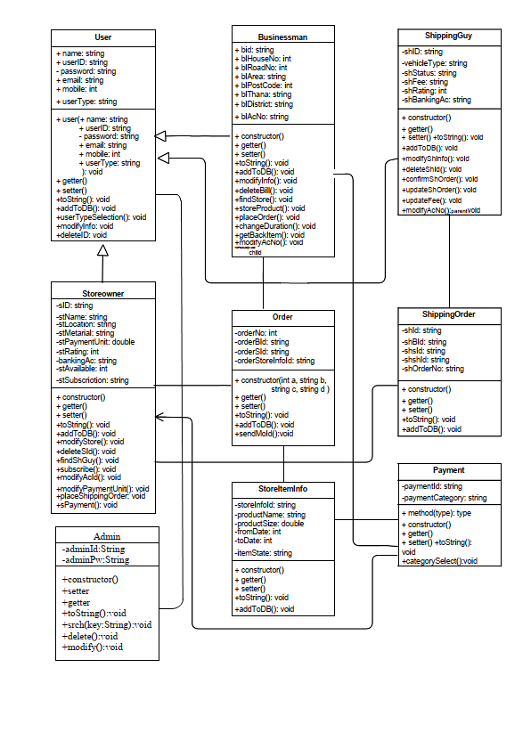Class Diagram:

UML Class Diagram

Sequence Diagram:

